HSBC - Workflow Functional Document

Application: | NGERP-CENTRA
WorkFlow: | Procure To Pay
WorkFlow Item Name: | HSBC Process

Description
HSBC process _ its used for vendor payment gateway process (Compiere between bank payment gateway).

Work Flow Process:

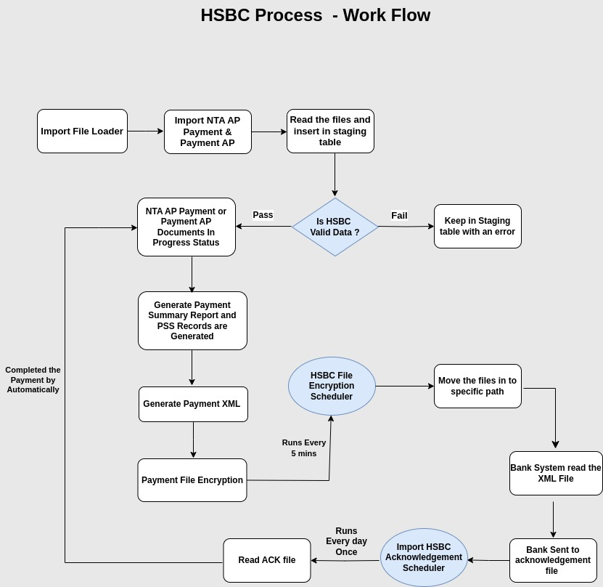

Business Rules:

- Import the 3A Payment HSBC file using the Import File Loader. The file name should start with "ImportPayment.csv."
- If the import file contains an error, it will remain on the staging screen. Otherwise, it will move to the NTA Payment AP (or Payment AP) screen in the "In Progress" state.
- In the NTA Payment AP (or Payment AP) screen, records are loaded into the "Generate Payment Summary Report," which shows only records in the "In Progress" state.
- The "Generate Payment Summary Report" displays records based on threshold limits. The user must select the records and process them.
- Once processed, a PSS Number is generated for the selected payments.
- After the PSS Number is created, the file moves to the "Generate Payment XML" screen, where the Payment XML file is generated.
- The Payment file encryption is handled by the HSBC File Encryption Scheduler, which runs every 5 minutes.
- The encrypted file is then moved from the file path "GP Encryption/Inbox/XML" to the bank's system.
- The bank's system will read the XML file, and send an acknowledgment file via the Import HSBC Acknowledgment Scheduler, which runs once every day.
- The Import HSBC Acknowledgment file is saved in the path "GP Encryption/Inbox/From Bank."
- Once the Import HSBC Acknowledgement file is received, the user must verify all NTA Payment AP records in the "In Progress" state. Once verified, the records will move to the "Complete" state.

